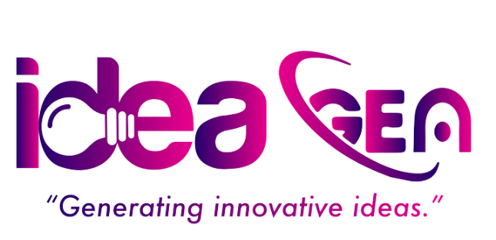

**WEBSITE DEVELOPMENT PROPOSAL**

**SUBMITTED TO**

**Jalupadevi Foreign Employment**

**IDEA GEN PVT. LTD.**

**PUTALISADAK, KATHMANDU, NEPAL**

# Introduction

Welcome to Idea Gen, a premier digital solutions company specializing in modern website development, digital strategy, and scalable tech solutions. This proposal outlines our plan to redesign the current ICTC website ([**https://ictc.com.np/**](https://ictc.com.np/)) using the Next.js framework to create a **modern, elegant, and performance-optimized web experience**.

The redesign aims to reflect ICTC’s prestige, long-standing legacy, and modern outlook while ensuring fast load times, mobile responsiveness, improved SEO, and intuitive navigation.

# Project Overview

The existing ICTC website offers rich corporate and investment insights but requires a significant upgrade in terms of design aesthetics, technical efficiency, and content structure. The redesigned site will:

* Showcase ICTC’s core services and subsidiaries.
* Reflect its leadership, history, and corporate values.
* Provide insights into its CSR efforts.
* Optimize performance using **Next.js** features like static generation, server-side rendering, and API routing.
* Be fully mobile-responsive and SEO-optimized.

# Web Page Structure

The website will include the following key sections:

## 1. Home Page

* Hero banner with company tagline and visuals.
* Brief about ICTC.
* Core services.
* News/Announcements.
* Call-to-action buttons for CSR, Careers, and Contact.

## 2. About Us

* ICTC history and legacy (established in 1973).
* Vision, mission, and values.
* Team/leadership overview.
* ISO certification details.

## 3. Services

* Representation & Liaison Services.
* Investment portfolios (real estate, finance, insurance).
* Engineering and management consultancy.

## 4. Subsidiaries & Affiliates

* Overview and details on:
  + ICTC Real Estate Pvt. Ltd.
  + Highland Distillery.
  + Other affiliate companies.

## 5. CSR (Corporate Social Responsibility)

* Overview of IRRT (ICTC Ram Rukmani Charitable Trust).
* Projects in education, health, and social awareness.
* Gallery and testimonials (if available).

## 6. Careers

* Why work at ICTC?
* Available job openings.
* Application process and CV submission form.

## 7. News & Events

* Press releases.
* Events calendar.
* Photo and video gallery.

## 8. Contact Us

* Location details (Head Office, Branches).
* Google Maps integration.
* Contact form.
* General inquiries and support.

# Technology Stack

* **Frontend Framework**: Next.js (React-based)
* **Backend/API Routes**: Strapi CMS
* **Database**: PostgreSQL
* **Styling**: Tailwind CSS for fast, responsive, modern UI
* **Image Optimization**: Next.js Image component with lazy loading
* **SEO Optimization**: Head management, sitemap generation, schema markup
* **Hosting**: Custom VPS

# Estimated Timeline

|  |  |
| --- | --- |
| **Phase** | **Duration** |
| Requirement Analysis & Plan | 3 days |
| UI/UX Design | 6 days |
| Development (Frontend & API) | 16 days |
| Database Integration | 8 days |
| Testing & QA | 3 days |
| Deployment & Final Review | 2 days |

***Total Estimated Time:*** *Approx. 5 weeks (38 days) including development, testing, and deployment.*

# Costs

|  |  |
| --- | --- |
| **Item** | **Cost (NPR)** |
| Website Design & Development | NPR xx,xxx |
| Domain & Hosting (Annual) | NPR x,xxx |
| **Total** | **NPR xx,xxx** |

*Note: The above amount excludes VAT. 13% VAT will be added to billing.*

# Payment Terms

The proposed payment terms for the website development project are as follows:

* **40% Advance Payment:**  
  Payable during the agreement signing process to initiate the project.
* **60% Final Payment:**  
  Payable during the deployment of the website, signifying the completion of the project and the delivery of the complete website.

# Support Services

We provide **3 months of free post-development support**, covering minor bug fixes and technical assistance. Any extended maintenance will require a separate agreement based on the client's requirements.

**After the 3-month free support period**, an **Annual Maintenance Contract (AMC)** will be required, amounting to **20% of the total project budget**. This will cover ongoing technical support, updates, and maintenance to ensure the platform remains secure and up to date.

# Conclusion

Thank you for the opportunity to submit this proposal. We believe a redesigned digital presence for ICTC will not only modernize your brand’s online image but also improve information accessibility and engagement across your stakeholders.

We look forward to helping ICTC set a new benchmark in corporate web presence.

Best Regards,

**Er. Shailesh Shankhi**  
Chief Executive Officer  
**Idea Gen Pvt. Ltd.**